

Between War and Peace, The New Warfare Era
Andres Tello Borrero – 5026054
Military Approaches to Security – POL322G
Prof. Koen Troch
October 22, 2025

Word count: 2464

Summary
Technological development has transformed not only global communication but also the nature of power projection, military strategy, cybersecurity, disinformation, and contemporary warfare. Conflicts are no longer declared in the traditional sense; instead, the international arena is increasingly characterized by constant, low-intensity confrontation that operates in the grey zone between peace and war. States such as the Russian Federation and China, as well as certain actors in the Middle East, have systematically employed intelligence operations, propaganda, disinformation campaigns, political destabilization, and limited military force within the broader framework of what is now termed hybrid warfare.

The European Union and the North Atlantic Treaty Organization (NATO) have been compelled to react rapidly to these evolving threats. Hybrid warfare poses a particular regulatory challenge, as existing legal frameworks are ill-equipped to prohibit—or even define—such tactics. Moreover, an overly rigid legal response could prove counterproductive, as it might later be exploited strategically by hostile actors. The seriousness of this issue has led EU and NATO allies to engage in coordinated consultations for more than a decade to develop a cohesive response strategy.
Current preparations have focused largely on strengthening intelligence capabilities to detect, attribute, and analyze potential hybrid attacks. Member states contribute to this collective effort by reinforcing their domestic resilience, while NATO provides technical and strategic assistance in areas such as public awareness campaigns, cyber defense, and counterterrorism. The EU, by contrast, plays a central role in developing the legal and regulatory dimension of hybrid threat governance.

Although these initiatives represent meaningful progress, they remain insufficient to guarantee full security for European citizens. Effective deterrence requires not only institutional coordination but also public awareness and societal resilience. For this reason, both NATO and the EU should priorities the dissemination of educational material on hybrid threats across all member states, beginning at an early age, and should further deepen cooperation with private-sector actors. Within the EU context, Article 114 TFEU remains a crucial legal instrument and should continue to serve as a cornerstone of the Union’s strategy against hybrid threats.

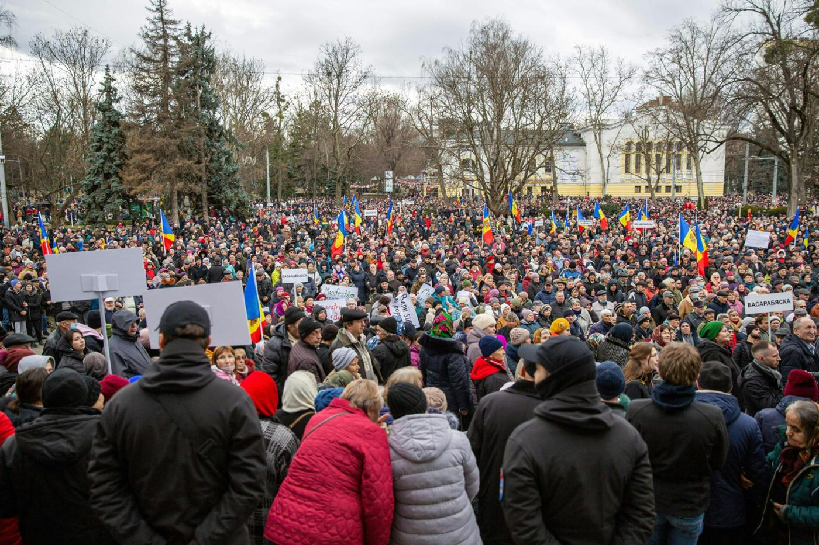

Understanding Hybrid Warfare
The 21st century has been a time of political, economic, and social changes that have drastically transformed the global defense system. Nations and international organizations such as the European Union (EU) and the North Atlantic Treaty Organization (NATO) can no longer rely only on military power to achieve their strategic goals. Modern operations now include other elements used by world powers, one of the most active being Russia against its rivals. Intelligence services, propaganda, disinformation, the creation of political instability, and military force are all part of a new strategy known as hybrid warfare. This approach highlights the alternative tools that ambitious states use to achieve their strategic objectives when facing diplomatic conflict with another country. “NATO member states have also begun to build specialized military formations to support defense against hybrid attack and deal with hybrid conflict elsewhere. A prominent example is the British 77th Brigade, a combined Regular Army and Army Reserve unit. Recently formed, the 77th Brigade focuses on intelligence, surveillance, and reconnaissance. It is designed to conduct modern information operations, particularly to counter hybrid warfare” (Giegerich, 2016, p. 70). One of the best-known cases is Georgia’s aspiration to join NATO. Its growing relationship with the EU was seen by Russia as a threat to its national security. In 2008, Russia intervened militarily in the region of South Ossetia, and the Kremlin’s recognition of two republics within Georgia ended Georgia’s hopes of joining NATO. This demonstrates how Russia uses ideology, social division, and internal destabilization as examples of hybrid warfare a pattern of behavior Moscow has repeatedly shown toward the West. The attack strategies employed today represent a subtle form of the art of war, allowing states to engage in conflict while circumventing international law.

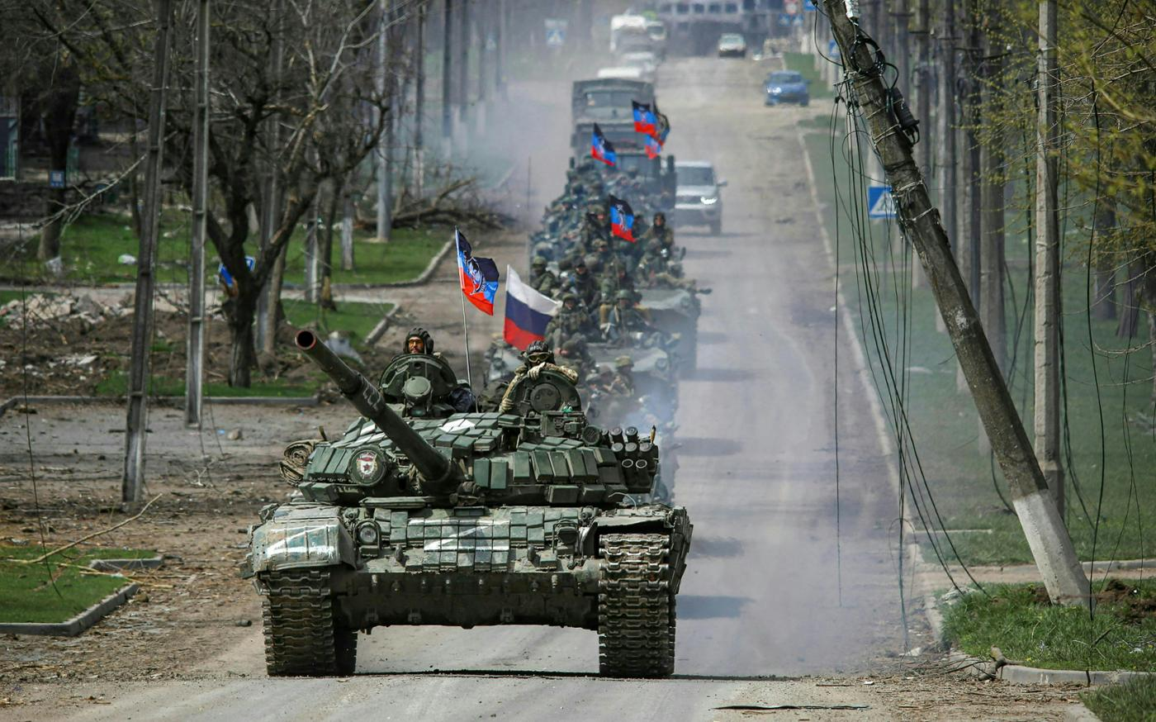

Hybrid Warfare as the “New Normal”
Conventional wars have lost much of their value as a means of achieving political objectives. The growing popularity and normalization of the method known as hybrid warfare can be attributed to its economic efficiency compared to the high costs of relying solely on military forces and traditional armed attacks whenever a state employs the use of force against another state or organization. As Bekkers (2019, p. 7) notes, “Hybrid threats can range from cyberattacks on critical information systems, through the disruption of critical services such as energy supplies or financial services, to the undermining of public trust in government institutions or the deepening of social divisions.” We live in an era in which global digital dependence is of critical importance for governments and international actors. The intelligence operations of states such as the United States, China, Russia, and members of the European Union are increasingly focused on protecting themselves against threats from rival powers. This represents a strategic tactic that is often employed as a first line of action due to its effectiveness and lower cost compared to conventional warfare.

A prominent and illustrative case of hybrid tactics is Russia’s ongoing use of this approach under General Valery Gerasimov, the commander of Russian forces in Ukraine. Russia has repeatedly employed hybrid warfare, culminating in the current large-scale invasion. As Schnaufer (2017, pp. 20–21) explains, “Russia has carried out this unfamiliar template in Ukraine, Syria, across Europe, and elsewhere. Russia has conducted multiple non-linear actions to observe the response of the United States and the North Atlantic Treaty Organization (NATO). General Gerasimov further declared, ‘The very “rules of war” have changed. The role of nonmilitary means of achieving political and strategic goals has grown, and, in many cases, they have exceeded the power of force of weapons in their effectiveness”. The normalization of hybrid warfare within international relations is increasingly evident, particularly in the Global South and East, placing the West and the international legal system governing the use of force in a position of vulnerability and frustration. Democratic governments are exposed to continuous threats within this evolving hybrid conflict environment.

NATO and EU responses so far
In addition to nation-states, two key international organizations play a central role in safeguarding the West: The European Union (EU) and the North Atlantic Treaty Organization (NATO). Both institutions are dedicated to protecting the socioeconomic, political, and security interests of Europe and the United States against threats primarily originating from the Russian Federation and the People’s Republic of China.

Since 2015, NATO has been developing strategies to counter hybrid threats faced by its member states. These preparations have focused largely on enhancing intelligence capabilities to detect and analyze potential threats or attacks. Allied states contribute to this collective effort by strengthening their domestic vulnerabilities, and, upon request, NATO can provide expert support in several areas, including “civil preparedness and chemical, biological, radiological and nuclear (CBRN) incident response; critcal infrastructure protection; strategic communications; protection of civilians; cyber defense; energy security; and counterterrorism. Training, exercises and education also play a significant role in preparing to counter hybrid threats. This includes exercising of decision–making processes and joint military and non-military responses in cooperation with other actors” (NATO 2024).

The fight against hybrid threats cannot be undertaken in isolation. In this regard, the European Union has expressed a shared commitment to collective protection and has strengthened cooperation with NATO. The EU’s efforts have been particularly focused on cybersecurity, strategic communication, and practical joint exercises to ensure preparedness for potential conflicts or hybrid activities occurring within allied territories.

The international order and its governing legal frameworks are increasingly being undermined by the improper conduct of global powers such as Russia and certain actors in Southeast Asia, whose persistent provocations at the threshold between peace and conflict have generated significant concern across the West. Although NATO has developed a strategic framework to address these challenges, it requires strong collaboration with the European Union (EU) to ensure collective readiness and resilience against emerging hybrid threats. As emphasized by the Council of the European Union, “The EU-NATO strategic partnership is crucial to maintaining security and stability in the Euro-Atlantic area. EU-NATO initiatives in the field of countering hybrid threats include common proposals for cooperation related to hybrid threats, a structured dialogue on resilience beginning in 2022. The EU and NATO also carry out joint exercises in the field of crisis management, called parallel and coordinate (PACE). The 2024 exercise aimed to strengthen the EU’s ability to respond to potential hybrid crises, both inside and outside the EU” (Consilium 2024).
These efforts reflect the need for caution in determining the legal boundaries for the use of force and defense in response to increasingly frequent threats. The EU has taken additional steps by establishing a Hybrid Toolbox, designed to enhance coordinated responses to complex hybrid campaigns. According to the Council, “The toolbox comprises the preventive, cooperative, stability-building, restrictive, and support measures as set out in the 21 June 2022 Council conclusions on a framework for a coordinated EU response to hybrid campaigns. The purpose of the toolbox is to help identify complex and multifaceted hybrid campaigns, coordinate tailor-made and cross-sectoral responses. Acting as an overarching framework, it brings in other relevant response mechanisms and instruments, such as the foreign information manipulation and interference (FIMI) toolbox. In addition to this, the EU has developed the cyber diplomacy toolbox to respond to cyber threats and attacks” (Consilium 2024).

While these initiatives represent significant progress, they do not yet guarantee full security for European citizens. Recent cyberattacks on airports in countries such as Belgium and Germany, allegedly perpetrated by hostile actors, demonstrate the continued persistence of hybrid aggression aimed at destabilizing the European Union. The policies adopted so far provide important preventive measures but remain insufficient as a long-term defense solution, particularly if Eastern powers persist in adopting assertive and destabilizing behavior toward the West.

EU and NATO Challenges
The international community is aware of the growing threat posed by hybrid warfare; however, no legal limitations currently exist that provide certainty or effective deterrence against imminent attacks on peace and stability. The European Union has implemented preventive education policies and cybersecurity measures to counter external interference, and NATO has undertaken similar initiatives. Nevertheless, these efforts remain largely communicative and civilian in nature. There is still no specific international legal framework regulating hybrid warfare, which creates a significant vulnerability for supranational stability in Europe and for transatlantic relations. The partnership between these two institutions remains essential for safeguarding the security and peace of the Western world.

Historically, individual and state ambition has been a driving force behind international conflict, and wherever power exists, competition to obtain or preserve it will follow. EU member states can at times act in self-interest, prioritizing national strategic goals over collective security obligations. This lack of cohesion weakens the development and implementation of NATO–EU policies, as the differing geopolitical priorities of each state hinder the establishment of a unified and comprehensive response to hybrid threats.
Hybrid warfare is a concept widely recognized among diplomats and policymakers, but it remains largely unfamiliar to the public. Although educational assistance programs are available to citizens when requested by member states, these measures are insufficient if long-term preparedness is the goal. It should be considered obligatory for both the EU and NATO to actively disseminate information and educational content on hybrid threats across all member states, beginning from an early age. Likewise, collaboration with private-sector actors should be encouraged. “Close cooperation with the private sector is vital, and this is the most likely long-term impact of any legal framework that may be developed to challenge hybrid threats. The threats are not only tackled, but also put by companies or individuals whose affiliation with a sovereign state is always more or less plausibly deniable (Hummelbrunner et al. 2021).” Allowing for mutually beneficial partnerships whether economic or reputational so that responsibility does not rest solely on international institutions but is shared more broadly across society.

From the perspective of international order, it is widely acknowledged that current norms are at risk of erosion due to the actions of powerful states that challenge them without fear of sanctions, knowing that Western governments generally seek to avoid large-scale conflict due to the destructive and counterproductive nature of war. As a result, efforts continue to rely heavily on surveillance, monitoring systems, and early-warning mechanisms designed to detect and mitigate threats within European and transatlantic territories. It is therefore essential to alert allied states and encourage them to adopt policies that prioritize knowledge, public awareness, and precautionary measures, so that societies are adequately prepared to confront potential hybrid threats should they intensify in the future.

The twenty-first century has been defined by digital interconnection on an unprecedented scale. Terrorist organisations and certain governments have increasingly exploited this environment as a vehicle for disinformation, political manipulation and social destabilisation, often without facing any meaningful accountability. In response to these emerging risks, the European Union has sought to strengthen its legal framework, relying on Article 114 of the Treaty on the Functioning of the European Union (TFEU) as a basis for regulating the misuse of digital platforms. As Hummelbrunner et al. (2021) argue, hybrid threats encompass such a wide range of security concerns that a single comprehensive legislative measure would neither be feasible nor necessarily desirable; however, if one were to exist, it would most likely be grounded in Article 114 TFEU rather than in emergency powers or constitutional overhaul. Addressing hybrid threats today, however, requires more than the creation of legal sanctions: it depends on close cooperation with civil society and the private sector, including public education on the risks posed by disinformation and the irresponsible use of social media. In this respect, Article 114 TFEU constitutes a crucial legal instrument and should remain central to EU efforts to counter hybrid threats.

In the second quarter of 2025, the European Commission launched a new initiative called ProtectEU, aimed at countering hybrid threats and calling on professionals in defense, security, and cybersecurity to join the team. As Pachulski (2025) notes:
“This isn’t just policy for policy’s sake. The EU is adapting to a threat landscape where cyberattacks, influence operations, and physical sabotage are no longer siloed. These are coordinated campaigns that strike across domains—without declaring war. Recent examples include the pro-Russian hacktivist group KillNet launching DDoS attacks on hospitals and logistics providers in multiple EU countries, and sabotage operations targeting rail and energy infrastructure in Germany and Poland.”
The actions taken by the EU are applied immediately due to the severity of these threats. Recommended measures include creating a specialized, covert team responsible for addressing cybersecurity incidents, detecting threats, and alerting relevant authorities so they can respond appropriately, including the use of force if necessary, as international law and order are increasingly bypassed for the benefit of ambitious states. Hybrid warfare is currently being used as a method to avoid large-scale invasions while simultaneously achieving economic and military advantages.

Bibliography

Bekkers, F. et al. (2019) HYBRID CONFLICTS: THE NEW NORMAL? https://www.tno.nl/publish/pages/7427/tno-2019-hybride.pdf.

Consilium. (2019). Hybrid threats. [online] Available at: https://www.consilium.europa.eu/en/policies/hybrid-threats/#russia [Accessed 17 Oct. 2025].

Hummelbrunner, S., Kirchmair, L., Pirker, B., Prickartz, A.-C., Staudinger, I. and Lonardo, L. (2021). (CC BY-NC-ND 4.0) Articles Shaping the Future of Europe -Second part edited by EU Law Against Hybrid Threats: A First Assessment. [online] 6(2), pp.1075–1096. doi:https://doi.org/10.15166/2499-8249/514.

NATO, 2023. Countering hybrid threats [online]. Available at: https://www.nato.int/nato_static_fl2014/assets/pictures/images_mfu/2023/7/topics/230705-topic-hybrid_rdax_775x440s.jpg [Accessed 22 October 2025].

NATO, 2023. Moldova pro-Russian protest [online]. Available at: https://www.nato.int/docu/review/images/a9896a_3_bilal_moldova-pro-russian-protest_cnn_article.jpg [Accessed 22 October 2025].

NATO, 2023. Russian convoy in Mariupol [online]. Available at: https://www.nato.int/docu/review/images/a9896a_4_bilal_russian-convoy-in-mariupol_reuters.jpg [Accessed 22 October 2025].

NATO (2024). NATO’s response to hybrid threats. [online] NATO. Available at: https://www.nato.int/cps/en/natohq/topics_156338.htm.

Pachulski, K., 2025. A strategic shift in how the EU confronts hybrid threats. Red Cell Security. Available at: https://www.redcellsecurity.org/post/a-strategic-shift-in-how-the-eu-confronts-hybrid-threats [Accessed 22 October 2025].

Partnership for Peace Consortium of Defense Academies and Security Studies Institutes and Giegerich, B. (2016) 'Hybrid warfare and the changing character of conflict,' Connections, 15–15(2), pp. 65–72. https://www.jstor.org/stable/10.2307/26326440.

Schnaufer, T. (2017) 'Redefining Hybrid Warfare: Russia’s Non-linear War against the West,' Journal of Strategic Security, 10(1), pp. 17–31. https://doi.org/10.5038/1944-0472.10.1.1538.

Staff, S. (2023). How Russia’s Hybrid Warfare is Changing | Small Wars Journal by Arizona State University. [online] Small Wars Journal by Arizona State University. Available at: https://smallwarsjournal.com/2023/07/17/how-russias-hybrid-warfare-changing/ [Accessed 6 Dec. 2024].

Ratsiborynska, V. and NATO Defense College (2016) When hybrid warfare supports ideology: Russia Today, Research Division. Research Paper 133. NATO Defense College, pp. 1–2. http://www.ndc.nato.int.

